**QUESTION 1**

**RESULTS**

**NAGINENI SAI LASYA**

**16353784**

VISUALIZATIONS:

Here, a box plot between Grip Strength and Frailty.

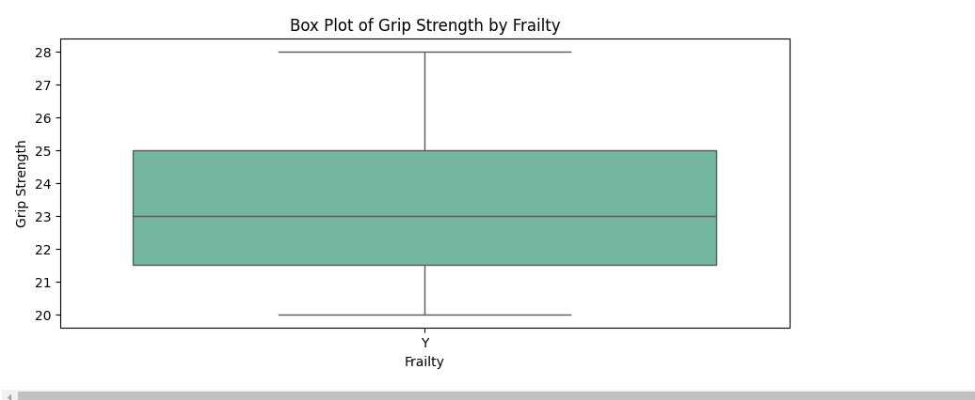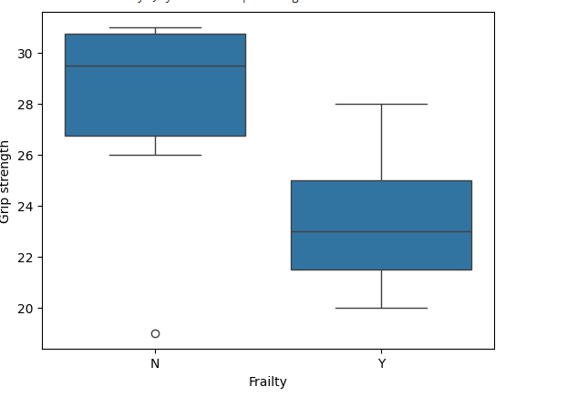

From above visualization, it clearly understands that Higher Grip strength results no Frailty and less Grip strength resulting Frailty issues.